Biographical information; Dr. Roger Hegarty

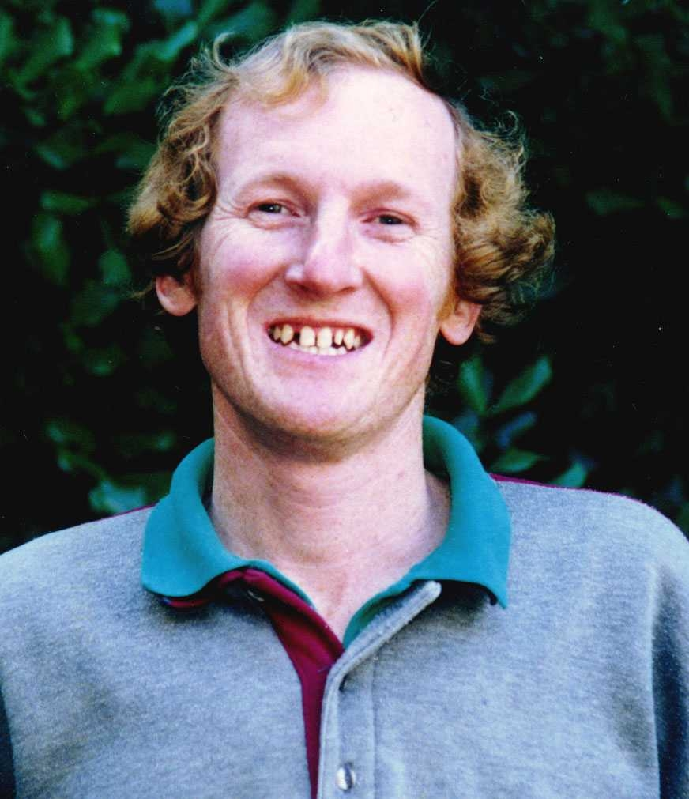
Dr. Roger Hegarty is a livestock nutritionist and currently visiting senior scientist at AgResearch, New Zealand. His principal research theme in recent years has been evaluation of practical or near practical strategies for mitigation of enteric methane production from ruminants. These have included studies and/or modelling of emission changes arising from pasture improvement, from selection of cattle for improved net feed intake and from elimination of rumen protozoa. He has an ongoing interest in study of methane measurement systems for grazing animals and in genetic improvement of livestock for GHG outcomes. When not on short term placement with AgResearch he is based with NSW Department of Primary Industries, Armidale, Australia.

